# Smart Classroom

Submitted in partial fulfillment of the requirements of

**Major Project**

for

Fourth Year of Computer Engineering

By

Abhishek Yadav 20102B0025 Siddhesh Varpe 20102A0023 Swathy Ayyangar 20102B0057

Under the Guidance of

Prof. Sneha Annappanavar

Department of Computer Engineering

**(An Autonomous Institute Affiliated to University of Mumbai)**

Vidyalankar Institute of Technology Wadala(E), Mumbai-400437

University of Mumbai 2023-24

1

**CERTIFICATE OF APPROVAL**

This is to certify that the project entitled **“Smart Classroom”**

is a Bonafede work of

**Abhishek Yadav 20102B0025 Siddhesh Varpe 20102A0023 Swathy Ayyangar 20102B0057**

submitted to the University of Mumbai in partial fulfillment of

##### Major Project

for

Fourth Year of Computer Engineering

Guide Head of Department Principal Prof. Sneha Annappanavar

2

# Major Project Report Approval

This project report entitled ***Smart Classroom*** by

1. ***Abhishek Yadav 20102B0025***
2. ***Siddhesh Varpe 20102A0023***
3. ***Swathy Ayyangar 20102B0057***

is approved for Major Project for Fourth Year of Computer Engineering.

|  |  |
| --- | --- |
| Internal Examiner | External Examiner |

Date:

Place: Wadala

3

# Declaration

We declare that this written submission represents my ideas in my own words and where others' ideas or words have been included, we have adequately cited and referenced the original sources. We also declare that we have adhered to all principles of academic honesty and integrity and have not misrepresented or fabricated or falsified any idea/data/fact/source in my submission. We understand any violation of the above will be cause for disciplinary action by the Institute and can also evoke penal action from the sources which have thus not been properly cited or from whom proper permission has not been taken when needed.

Name of student Roll No. Signature

1. Abhishek Yadav 20102B0025
2. Siddhesh Varpe 20102A0023
3. Swathy Ayyangar 20102B0057

Date:

Place: Wadala

4

Acknowledgements

This Project wouldn’t have been possible without the support, assistance, and guidance of several people whom we would like to express our gratitude to. First, we would like to convey our gratitude and regards to our mentor **Prof. Sneha Annappanavar** for guiding us. It was a great privilege to work and study under her guidance.

We would like to extend our heartfelt thanks to our Head of Department, **Dr. Sachin Bojewar** for overseeing this initiative which will in turn provide every Vidyalankar student a distinctive competitive edge over others.

We appreciate everyone who spared time from their busy schedules and participated in the survey. Lastly, we are extremely grateful to all those who have contributed and shared their useful insights throughout the entire process and helped us acquire the right direction during this research project.

5

Abstract

This project proposes an integrated framework for the development and implementation of a technologically enhanced smart classroom environment, aimed at revolutionizing traditional teaching methodologies and improving overall learning outcomes. Central to this framework are multiple innovative modules designed to address various challenges encountered in conventional classroom settings. Firstly, a Facial Recognition Attendance System is introduced to automate attendance tracking, eliminating the need for manual roll call, and optimizing time allocation for both students and educators. Complementing this, a Behavioural Analysis Module leverages facial expression recognition technology to capture real-time feedback from students, enabling teachers to tailor their instructional approaches based on individual student reactions and moods. Moreover, the project introduces cutting-edge teaching tools such as the Air Canva and Virtual PPT, which harness gesture and fingertip recognition to provide teachers with virtual whiteboard and presentation capabilities, fostering dynamic content delivery and interactive learning experiences. Additionally, the Shape Painter module offers the functionality to generate and manipulate virtual shapes on a digital canvas, further enhancing visual communication and instructional versatility. Through seamless integration of these modules, the proposed smart classroom environment aims to streamline administrative tasks, adapt teaching methodologies to individual student needs, and cultivate a collaborative and technologically immersed learning atmosphere conducive to academic success and student engagement. This project contributes to the ongoing discourse on the integration of technology in education and underscores the potential of smart classroom initiatives in reshaping the future of teaching and learning.

Top of Form

6

**Table of Content**

7

|  |  |  |
| --- | --- | --- |
| **Chp no.** | **Topic** | **Pg no.** |
| **[I]** | Introduction   * 1. Problem Definition   2. Aim and Objective   3. Scope of Project   4. Functionality of the Project   5. Constraints of the Project   6. Test Cases / Validation | 8 - 17 |
| **[II]** | Implementation Methodology  2.1 Design  2.1.1 Flow Diagram  2.1.2 Use Case Diagram  2.2 Hardware and Software Requirements  2.3 Backend Connectivity  2.4 Module Implementation  2.5 Code  2.6 Application | 18 - 37 |
| **[III]** | Summary  3.1 Complete Project Model  3.2 Future Implementations  3.3 Result  3.4 Future Scope  3.5 Conclusion | 38 - 44 |

* 1. **Introduction**Top of Form

In the contemporary landscape of education, technology has emerged as a powerful force, promising to reshape the way we teach and learn. This project proposes a comprehensive framework for the development of a smart classroom environment, leveraging various technological modules to address the shortcomings of traditional teaching methods. One key aspect is the use of facial recognition technology for attendance, which not only automates the mundane task of taking attendance but also ensures accuracy and timeliness. This allows teachers to focus more on actual instruction rather than administrative duties, thus optimizing classroom efficiency.

Furthermore, behavioral analysis tools offer real-time feedback on student engagement and comprehension. By analyzing facial expressions and body language, teachers can adapt their teaching methods on the spot, ensuring that each student receives personalized attention. This level of insight into student behavior enables educators to tailor their approach to individual learning styles, ultimately enhancing the learning experience for all students. Additionally, interactive teaching tools such as Air Canva and Virtual PPT encourage active participation and collaboration, making lessons more engaging and stimulating.

By exploring the potential of these modules within the context of a smart classroom, this research contributes significantly to the ongoing discourse on technology integration in education. It provides valuable insights into the transformative possibilities of advanced technological solutions in shaping the future of teaching and learning. Ultimately, the aim is to create an environment where both teachers and students can thrive, where administrative burdens are reduced, and where learning is personalized and dynamic. Through the adoption of such innovative approaches, education can evolve to meet the needs of the modern world.

8

### Problem Definition:

Nowadays, there has been a huge rise in online class mode option from the last few years of quarantine and as a result many are not used to the idea of working with the offline system of class and carry out its tasks. It’s a good but hard way as it can be difficult for system to get used to this sudden change and get over with it within a short amount of time.

One of the problems faced by college management staff is the low responsiveness of students during the lecture hours and can’t be helped as they themselves may feel the difference in change of modes a need for and solver for this issue.

Some of the students might not be able to carry out long distance traveling daily as their residence being too far away from the college their commutation is almost close to impossible daily. For them there will be requirement for change of this online / offline mode and need for a hybrid more.

The availability of the more facilities and ease of their access will make it more fun and easier for them to manage. As a result, it will cause issue if ignored and if resolved it will be for the betterment of educational system and will hugely increase the level of quality of time made into utilization.

9

### 

### Aim and Objective:

The overarching aim of this project is to conceptualize, design, and implement a comprehensive smart classroom ecosystem that harnesses the potential of integrated technological modules to fundamentally transform the traditional educational paradigm, fostering a dynamic, interactive, and personalized learning environment conducive to academic excellence and student engagement.

* + 1. Develop and Deploy a Facial Recognition Attendance System to automate attendance tracking and streamline administrative processes.
    2. Design and Integrate a Behavioral Analysis Module capable of real-time feedback collection through facial expressions, enabling tailored teaching strategies.
    3. Create interactive teaching tools, including Air Canva and Virtual PPT, leveraging gesture and fingertip recognition for dynamic content delivery and enhanced engagement. The Shape Painter module enables virtual shape generation and manipulation, promising visual communication and instructional versatility.

### Scope of Project

The scope of the project is building a smart classroom environment which will be facilitating multiple facilities regarding the daily activities of a classroom or educational curriculum which will be helping both student and teaching staff to make it fun an interactive to attend college as everything will be made so easy. The project is in parts so we have implemented Face Attendance System, Behavioral Analysis System, Air Canva, Virtual PPT, Shape Painter (Air Canva & Virtual PPT & Shape Painter can be integrated into one single module of Smart board).

* + 1. About the daily classroom activities.
    2. The services offered on the portal.
    3. Interactive services.
    4. Better than traditional methods.

10

9

### 

### Features of the Project

##### Student Features:

##### Face Attendance - The student can access this feature through the application platform and mark up his attendance through the camera feed provided face recognition module implemented in the project.

##### Behavioral Analysis – This can be accessed by the student or set up to be used when the analysis data is to be collected for cluster study of students lecture strategy planning.

##### Educator Features:

##### Attendance Management – The educator will access the attendance database and will manage the attendance record and can generate reports.

##### Strategy Planning – The educator can study the data generated from behavioural analysis as a group student cluster data and can develop the future study plans as per the results of observation.

##### Air Canva – The educator can use this feature to go on a separate layer of page accessible through their fingertip recognition and gesture recognition to explain all stud they want without an actual physical board on a virtual board.

##### Shape Painter – The educator can use this feature to the draw definite shape like tables and lines and circles which serves the same purpose as Air Canva and can also be integrated into one single module.

10

##### Virtual PPT – The educator can use this feature to make use of virtual mode to teach students using PPT which will teach them lessons.

11

### Constraints on Project

Project Constraints can be anything that restricts the team output and affect the delivery process and final output of the project. The execution of the project can be affected at different stages and it can cause issues with the process, portfolio, and program of the project. Numerous project management constraints exist; some have listed:

* + 1. Time Constraints

The Smart Classroom project is expected to take 6-9 months. Planning will take 1-2 weeks, development 8-12 weeks, testing 2-4 weeks, and deployment and maintenance 1-2 weeks. Ongoing maintenance will require 1-2 weeks per month.

* + 1. Scope Constraints

The scope constraints of the Smart Classroom project encompass specific features like the Facial Recognition Attendance System, Behavioral Analysis, Air Canva, Virtual PPT Presenter, and Shape Painter. We'll use predefined technologies and frameworks, focusing on integration between modules. Testing will ensure functionality, but extensive user testing may be limited. Deployment will be in a controlled environment, and resource availability will determine project adjustments.

* + 1. Cost Constraints

The cost constraints of the Smart Classroom project include development hardware costs for cameras and interactive whiteboards, training expenses for educators and students, testing and quality assurance costs, deployment expenses, maintenance and support costs, and a contingency budget for unexpected expenses. The total cost will depend on factors such as project complexity, team size, duration, and additional requirements, requiring careful budgeting to stay within the allocated funds.Top of Form

* + 1. Quality Constraints

Quality constraints for the Smart Classroom project are crucial to ensure its effectiveness and reliability. The system must accurately track attendance, analyze student behavior, and enable smooth interaction with features like Air Canva and Virtual PPT Presenter. User-friendly interfaces are essential for educators and students, ensuring easy navigation and engagement. Performance is critical, with the system expected to operate efficiently and handle concurrent users seamlessly. These quality constraints collectively ensure that the Smart Classroom system delivers a reliable, user-friendly, and secure environment for optimized teaching and learning experiences.

* + 1. Risk Constraints

Risk constraints for the Smart Classroom project include technical challenges in implementing complex technologies, resource shortages, schedule delays, integration challenges, vendor dependencies, and environmental factors. Addressing these risks early in the project is crucial to minimize their impact and ensure the successful implementation of the Smart Classroom system.

12

11

### Test Cases / Validation

##### 1.7.1 Testing

Three goals were identified for the test plan: reliability, security, and usability. Reliability and security testing was accommodated by constructing test cases and comparing expected and actual results. Usability testing, however, is completely different. Usability testing requires domain experts to use the software and deploy the software in a restaurant environment. Due to the time constraints of the project we were unable to perform any formal usability testing using persons external to the development team. Types of Testing

* Black Box Testing
* White Box Testing
* Integration Testing

We have implemented various test cases on our software i.e., the SMART CLASSROOM. A TEST CASE is a sequence of actions performed to ensure that a certain feature or operation of your software application is working properly. A Test Case contains test steps, data, preconditions, and post-conditions developed for specific test scenarios to verify any requirement. The test case contains specified variables or circumstances that a testing engineer might use to compare expected and actual outcomes to assess whether a software product meets the customer's needs.

##### TEST CASE: 01 FACE ATTENDANCE

|  |  |  |  |  |
| --- | --- | --- | --- | --- |
| Test id | Test cases | Actual Result | Test Result | Test id |
| 1. | Turning camera on to access the facility | Face recognition starts working | As expected, | Successful |
| 2. | Get face recognized as checked against database for similar match. | Code works and starts to recognize their face | As expected, | Successful |
| 3. | Check to get attendance marked | The user will recognize their face | As expected, | Successful |

12

13

**Table no:1 Face Attendance**

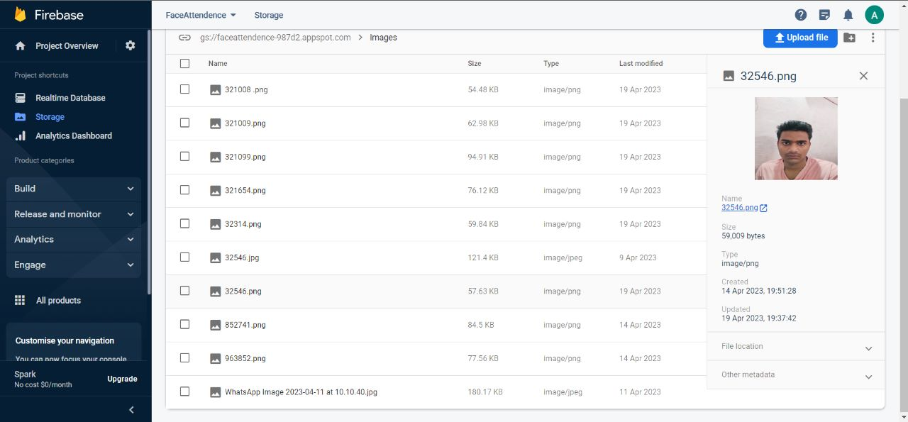

**Face Id Database**

**Attendance marking UI**

**Get Attendance Marked**

14

##### TEST CASE 02: BEHAVIOURAL ANALYSIS

|  |  |  |  |  |
| --- | --- | --- | --- | --- |
| Test id | Test cases | Expected result | Actual Result | Test Result |
| 1. | Starting up the  Emotion Detection | It starts Detecting faces | As Expected, | Successful |
| 2. | Turning camera on to access the facility | Expression recognition starts working | As expected, | Successful |
| 3. | Get face recognized as checked against dataset for similar match. | Code work and analyze starts to it | As expected, | Successful |
| 4. | Check to which class detected emotion belong | The scan user their will face | As expected, | Successful |

**Table no:2 Behavioral Analysis**

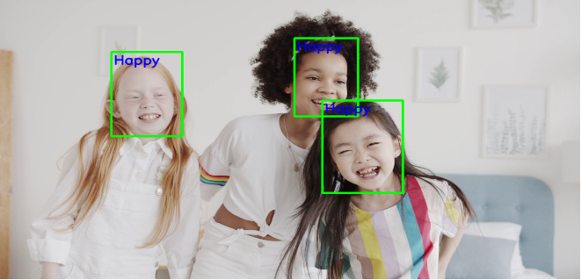

**Behavioral Analysis video test example**

15

##### TEST CASE 03: AIR CANVA & SHAPE PAINTER

|  |  |  |  |  |
| --- | --- | --- | --- | --- |
| Test id | Test Cases | Expected result | Actual Result | Test Result |
| 1. | Going to main login page. (can also login with google) | Enter the and provide credentials | As Expected, | Successful |
| 2. | Turning camera on to access the facility | Fingertip / Hand recognition starts working | As expected, | Successful |
| 3. | Get hand / fingertips recognized and check for gesture recognition match. | Code work and recognition starts. | As expected, | Successful |
| 4. | Action performed according to gestured detected | The action performed on gesture detected from the rules stated for each gesture | As expected, | Successful |

**Table no:3 Air Canva & Shape Painter**

**Air Canva UI being used to write down.**

16

##### TEST CASE 04: VIRTUAL PPT PRESENTER

|  |  |  |  |  |
| --- | --- | --- | --- | --- |
| Test id | Test Cases | Expected result | Actual Result | Test Result |
| 1. | Starting up the Virtual PPT Presenter | It starts Virtual PPT Presenter | As Expected, | Successful |
| 2. | Camera starts recognizing hand / fingertips | Hand locater locates the hand on screen | As expected, | Successful |
| 3. | The rules inscribed in the program is looked for while detecting hand | Gestures will be detected and will be performed action as moving ppt forward and backward using thumb. | As expected, | Successful |
| 4. | The rules inscribed in the program is looked for while detecting hand | Gesture will be detected, and action will be performed as marking upon the ppt | As expected, | Successful |

**Table no:4 Virtual PPT Presenter**

**PPT is presented and controlled using hand gestures and can be used as a whiteboard too.**

17

* 1. **Implementation Methodology**

### Design

##### Flow Diagram

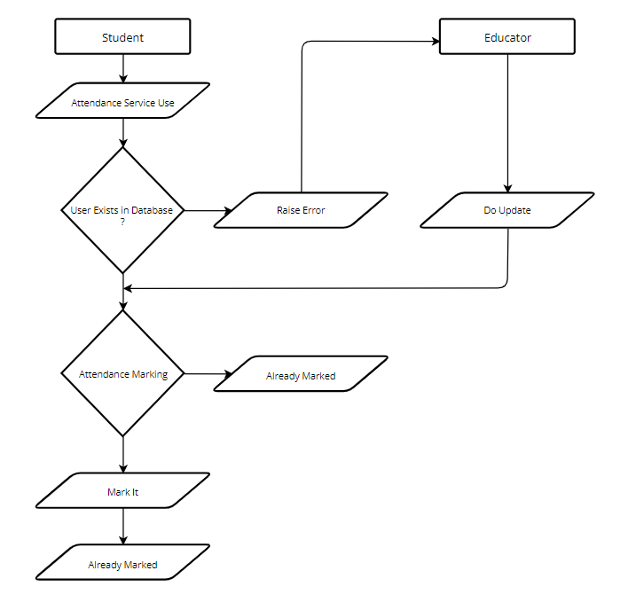

Yes

No

**Fig. 1**

**Face Attendance System – Flow Digram**

18

No

Yes

Update

Check and Revert

19

**Fig. 2**

**Behavioural Analysis – Flow Digram**

**Fig. 3**

**Air Canva & Shape Painter – Flow Digram**

20

**Fig. 4**

**Virtual PPT Presenter – Flow Digram**

21

##### Use Case Diagram

**Fig. 5**

**Face Attendance System, Behavioral Analysis**

22

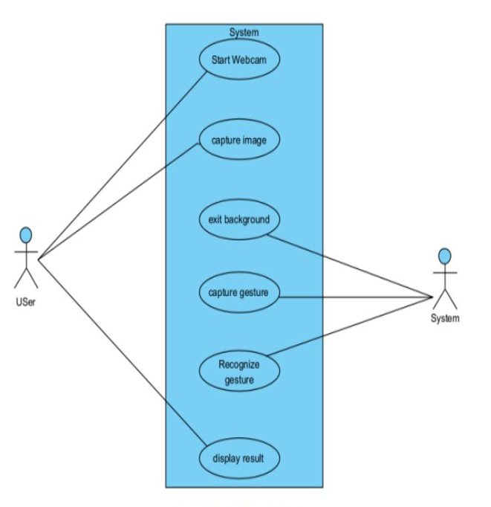

**Fig. 6**

**Air Canva, Virtual PPT, Shape Painter**

23

### Hardware and Software Requirements

##### Hardware Requirements

* Development – Core i5 4 GHz, 4 GB of RAM, 500 GB storage
* Client - P IV processor 2.0 GHz, 512MB of RAM, 40GB storage
* Server – Windows 2008 R2, processor 2.0 GHz, 8 GB RAM, 500GB storage

##### Software Requirements

* Scripting tool: PyCharm, VScode.
* Database tools: Firebase, Dataset.
* Compatible operating system: Windows, Mac.
* Front end design: Python3.
* Software tools: PyCharm, VScode, Firebase.

24

**2.3 Backend Connectivity:**

**[A] Database Connectivity For Face Attendance**

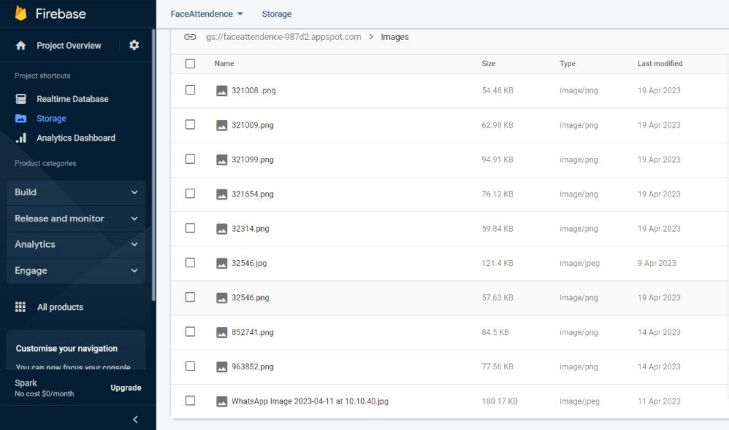

25

**[B] Data Set for Behavioural Analysis System**

### 

### 

24

26

### Module Implementation

**[A] Face Attendance System**

* **Add data to Database:**

This code is an example of using face recognition technology and Firebase to create a system for taking attendance using images of students' faces.

The code imports the necessary libraries such as cv2 for image processing, face_recognition for face detection and recognition, pickle for serialization of data, os for file system operations and firebase_admin for integrating with Firebase.

It then initializes a connection to the Firebase database and storage, using the provided serviceAccountKey.json credentials file. The storageBucket parameter specifies the default storage bucket to be used for storing images.

* **Encode Generator:**

Next, the code reads images of students' faces from a local directory specified in the folderPath variable using the os module. The images are then uploaded to Firebase storage by creating a Blob object and using the upload_from_filename() method.

The findEncodings() function is then defined, which takes a list of images as input and returns a list of their corresponding face encodings using the face_recognition library.

* **Main:**

Finally, the encodeListKnown list of face encodings for the known images is saved to a file named EncodeFile.p using the pickle library.

Overall, this code sets up the infrastructure for a facial recognition attendance system using Firebase, by reading images of students from a local directory, storing them in Firebase storage and computing their corresponding face encodings, which are then saved to a file for future use.

**[B] Behavioural Analysis**

* **EvaluateEmotionDetector:**

This is used to set up base parameters for the projects and get all requirements fulfilled for further execution of project. It sets up the libraries and base function and will be the parent class for other classes in inheritance , will be supporting reusability.

* **TestEmotionDetector:**

It is code to test the data where 70% of data is used for testing and 30% of data is used for training . The neural network sequential model is used here where the processing will be done in sequential manner and one process cant start unless previous is completed or skipped.

* **Emotion_detection_with_CNN-main:**

It will be the driving function of your application which will integrate the whole project and run it as oneOverall, this code sets up the infrastructure for a facial emotion recognition system using Python, by reading images of dataset from a local directory, comparing them in realtime.

27

**[C] Air Canva and Shape Painter**

* **HandDetector:**

Hand detection in Python is typically done using libraries like OpenCV, leveraging cascade classifiers or deep learning models such as SSD or YOLO. These tools enable the detection of hands in images or videos, offering both traditional and state-of-the-art methods for accurate results.

* **gestureThreshold function:**

This function sets the threshold for the height above or below which the hand detection will take place and above which the gesture performed will be captured and checked for the rules.

Top of Form

* **getTool function:**

This function will be used to get access to the tools of the painter such as circle, rectangle, line and clear tools which are present at the top for the application screen for use of user.

**[D] Virtual PPT Presenter**

* **HandDetector:**

Hand detection in Python is typically done using libraries like OpenCV, leveraging cascade classifiers or deep learning models such as SSD or YOLO. These tools enable the detection of hands in images or videos, offering both traditional and state-of-the-art methods for accurate results.

* **GestureThreshold function:**

This function sets the threshold for the height above or below which the hand detection will take place and above which the gesture performed will be captured and checked for the rules.

* **Hands and buttonPressed:**

This function checks out the hand detected for gesture rules inscribed in it , i.e. it checks which finger is raised whether its thumb, pinky , index or all or 3 prime fingers. The action is performed for the gesture detected.

28

### 

### Code:

**[A] Face Attendance System**

Main.py :

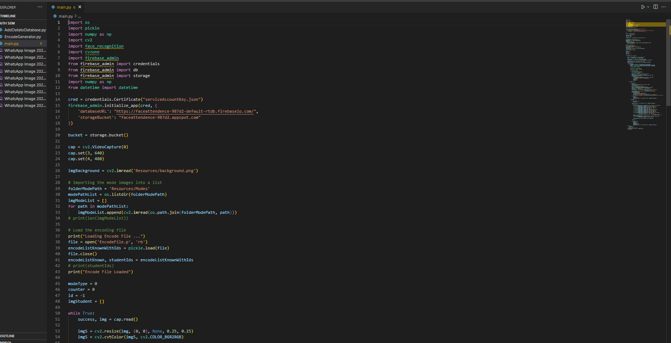

EncodeGenerator.py:

29

26

AddDatatoDatabase :

Setup **:**



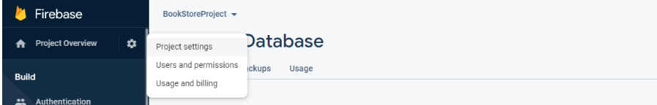

30

Syntax:

31

**[B] Behavioural Analysis System**

EvaluateEmotionDetector:

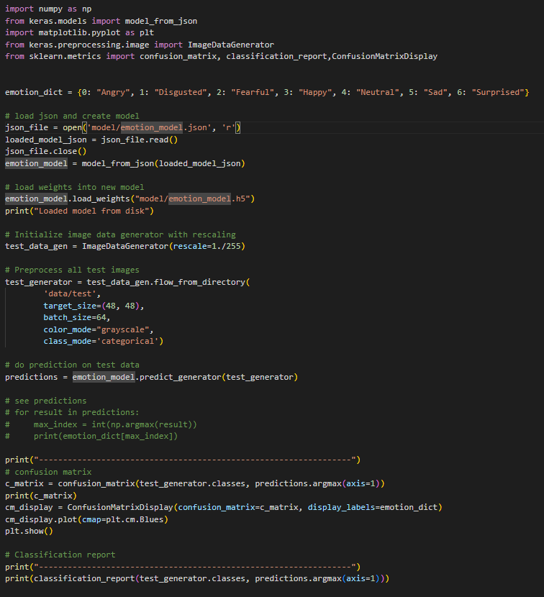

TestEmotionDetector:

32

TrainEmotionDetector:

Setup:

33

**[C] Air Canva and Shape Painter**

HandDetector.

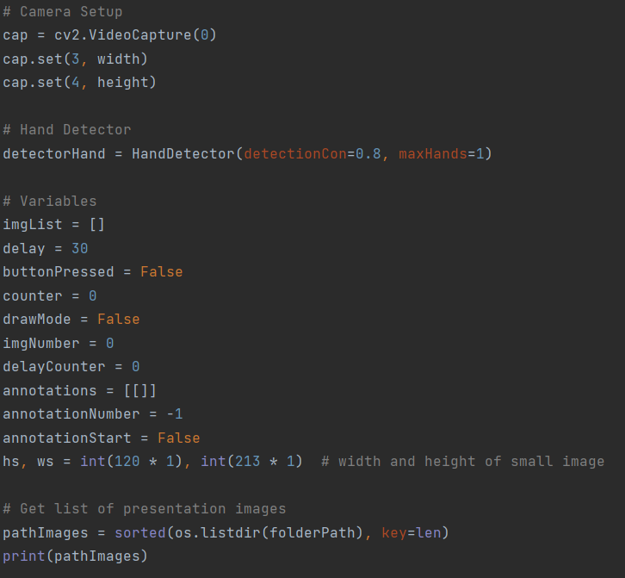

getTool.

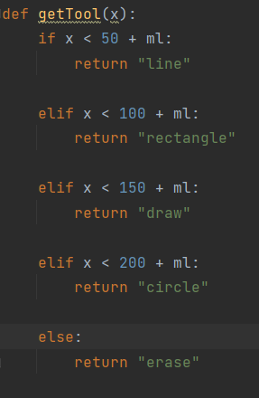

34

**[D] Virtual PPT Presenter**

gestureThreshold:

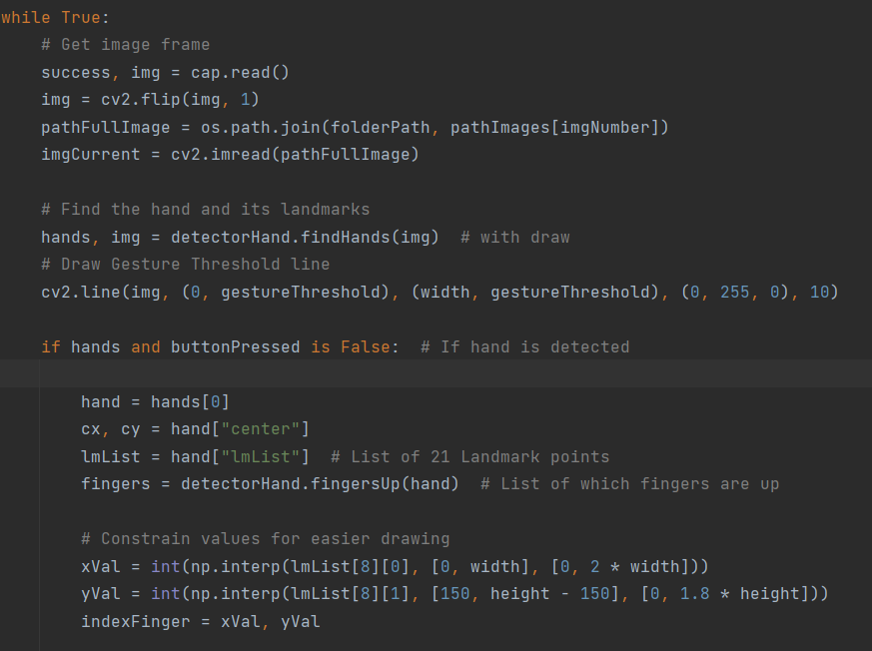

hands and buttonPressed:

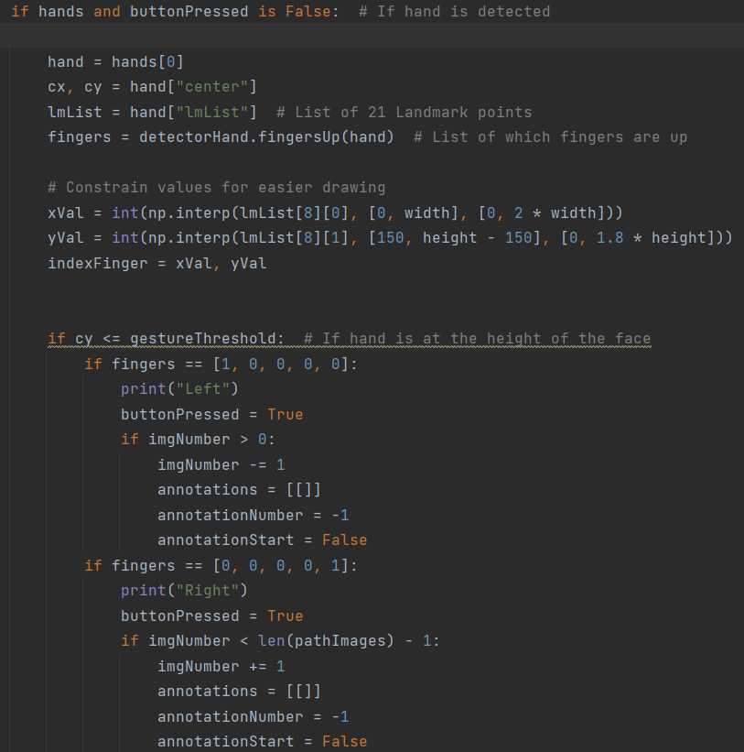

35

### 

### Applications

### [A] Face Attendance System

### Automated Attendance Tracking: Streamlines attendance recording, saving time and reducing errors.

### Efficient Record-Keeping: Creates digital attendance records for easy access and analysis.

### Real-time Monitoring: Identifies and addresses attendance issues promptly.

### Data Analytics: Provides insights into attendance patterns for informed decision-making.

### Parental Involvement: Keeps parents informed about student attendance and activities.

### Improved Accountability: Ensures students attend classes and tracks staff attendance.

### Secure Exam Administration: Verifies student identities during examinations, reducing cheating risks.

### Digital Sign-in for Events: Simplifies attendance management at school events and activities.

### [B] Behavioral Analysis System

### Student Engagement Monitoring: Analyzes expressions and body language for teacher adaptation.

### Feedback and Assessment: Provides real-time feedback to improve self-awareness.

### Special Needs Support: Helps teachers cater to students with special needs.

### Teacher Training: Assists in teacher development and classroom management.

### Assessment of Online Learning: Enhances remote teaching effectiveness.

### Research on Learning and Emotions: Contributes to curriculum and methodology improvements.

### Behavioral Management: Identifies signs of distress for discipline.

### Student Well-being Surveys: Provides objective emotional data for support initiatives.

36

### [C] Air Canva and Shape Painter

### Teachers can use Air Canva to deliver dynamic lectures, annotating slides or drawing diagrams in real-time, enhancing student understanding and engagement.

### Students can collaborate on projects or brainstorm ideas using Air Canva's virtual whiteboard, fostering teamwork and creativity.

### Teachers can use Air Canva to illustrate problem-solving processes, breaking down complex concepts into easily understandable steps.

### Students can create visually appealing presentations using Air Canva's features, incorporating images, diagrams, and annotations to enhance their communication.

### In one-on-one or small group tutoring sessions, tutors can use Air Canva to explain concepts, work through problems, and provide personalized assistance to students.

### Language teachers can use Air Canva to visually represent vocabulary words, grammar concepts, or dialogues, aiding in language acquisition.

### Students can use Air Canva to create concept maps or mind maps, organizing information and visualizing relationships between ideas.

### Storyboarding: In multimedia or creative arts classes, students can use Air Canva to storyboard projects, plan out scenes, and visualize their ideas.

### 

### [D] Virtual PPT Presenter

### Virtual PPT enables dynamic and interactive presentations, enhancing student engagement.

### It facilitates virtual instruction, ensuring continuity of learning in remote or hybrid settings.

### Teachers can tailor presentations to individual student needs, promoting personalized learning.

### Embedded quizzes and surveys allow for real-time assessment and feedback.

### Multimedia elements enhance understanding and retention of course material.

### Virtual PPT supports collaborative group work and presentations.

### It accommodates diverse learning needs with accessibility features like screen readers and closed captioning.

37

* 1. **Summa**

**3. Summary**

**3.1 Complete Project Model:**

**Fig. 7**

**Student Side Features Summary:**

* **Facial Recognition Attendance Taker:** Students can conveniently mark their attendance without the need for manual roll call, saving time and reducing administrative hassles.
* **Behavioural Analysis Module:** Students receive real-time feedback on their engagement and mood in class, allowing them to adjust their approach to learning accordingly.
* **Air Canva:** Students can view and interact with virtual whiteboard content created by teachers, enhancing visual learning and understanding of concepts.
* **Virtual PPT:** Students can follow presentations and lessons using hand gestures and fingertip recognition, promoting active participation and engagement.
* **Shape Painter:** Students can visualize concepts with shapes, tables, and diagrams, aiding in understanding and retention of course material.

**Educator Side Features Summary:**

* **Facial Recognition Attendance Taker:** Educators can effortlessly track student attendance, enabling them to focus more on teaching rather than administrative tasks.
* **Behavioural Analysis Module:** Educators receive insights into student engagement and mood, allowing them to adjust their teaching strategies to better meet student needs.
* **Air Canva:** Educators can create and annotate virtual whiteboard content, facilitating clearer explanations and visual demonstrations of concepts.
* **Virtual PPT:** Educators can deliver presentations and lessons with interactive elements, keeping students engaged and actively involved in the learning process.
* **Shape Painter:** Educators can create visual aids and diagrams to supplement their teaching, enhancing understanding and retention of information.

38

**3.2 FUTURE IMPLEMENTATIONS:**

In the future, integrating emerging technologies like AI and AR could personalize learning and create immersive experiences. Remote learning capabilities could extend access to education beyond the physical classroom, ensuring inclusivity. This ongoing advancement in technology has the potential to revolutionize education globally.

**3.4 RESULT:**

**[A] Face Attendance System**

When application is active, When Attendance is Marked and When Already marked still trying

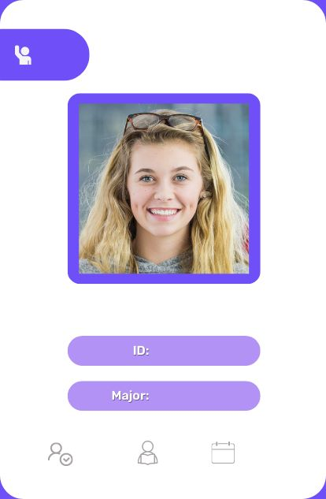

New User Admin can register

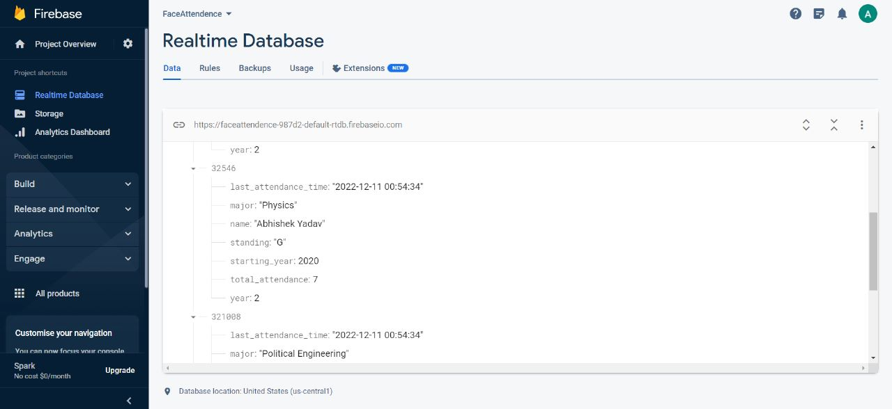

**New User Registration**

**n**

39

Registered Student Database of Attendance



40

**[B] Behavioral Analysis System**

When observed person was showing happy face

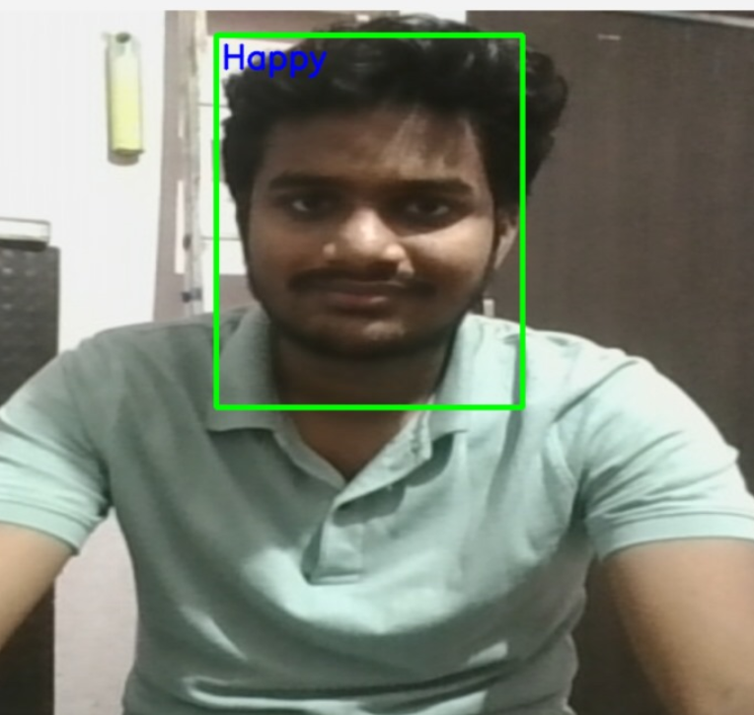

34

41

When observed person was showing neutral face

**[C] Air Canva**

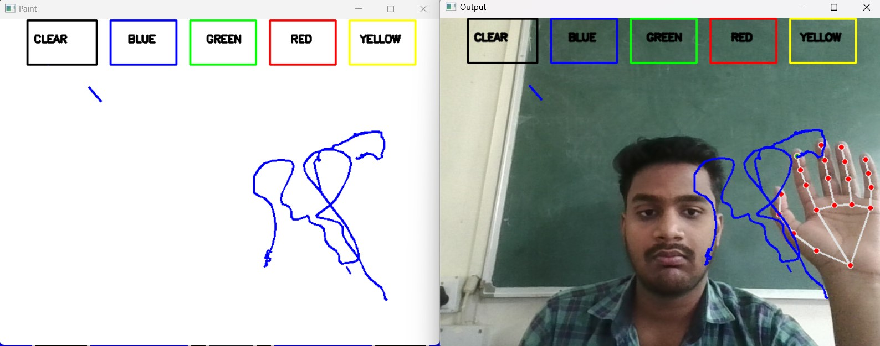

42

**[D] Virtual PPT presenter**

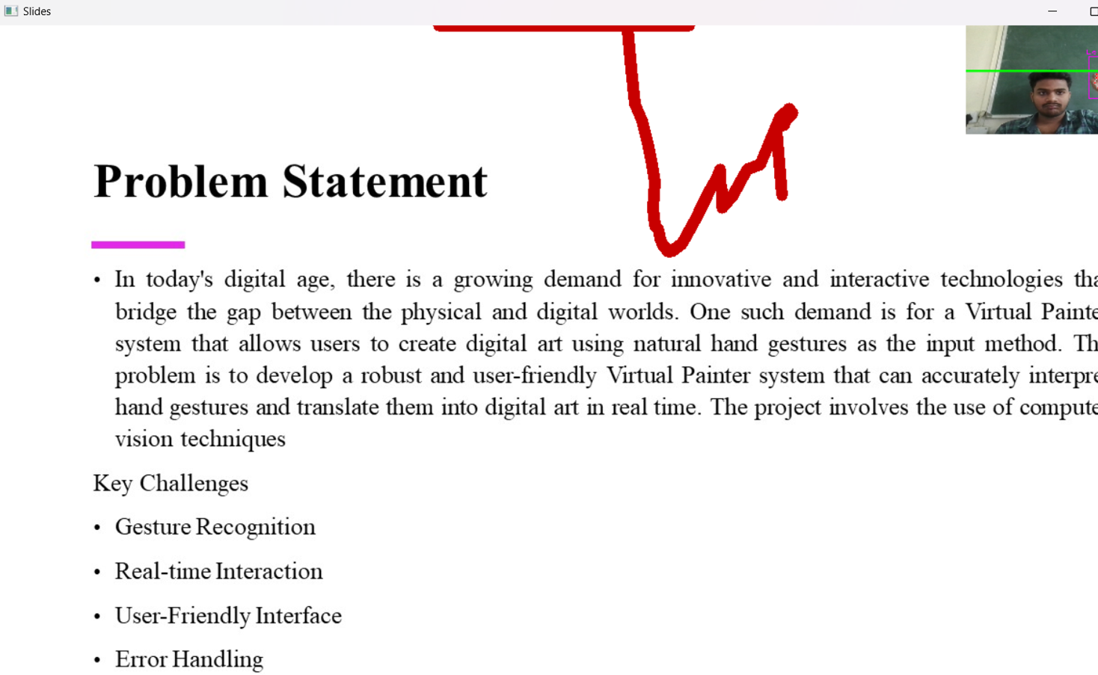

**[E] Shape Painter**

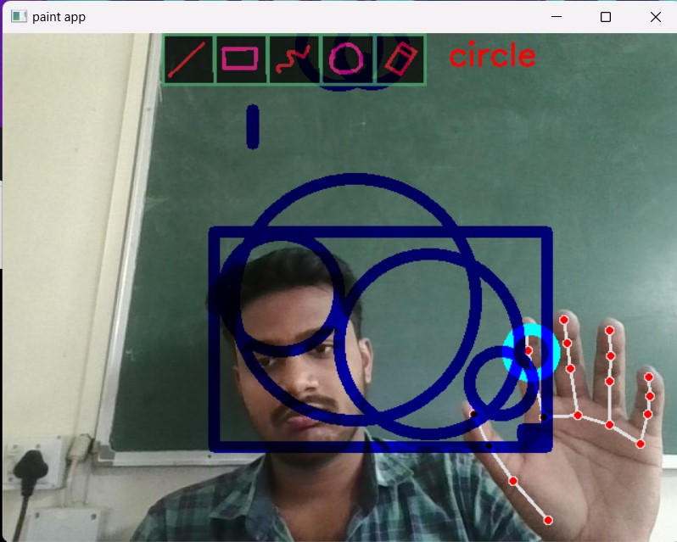

43

**3.4 FUTURE SCOPE:**

In the future, the smart classroom project holds significant potential for expansion and enhancement. Integrating artificial intelligence (AI) algorithms could personalize learning experiences, recommend content based on student needs, and provide adaptive assessments. Enhanced data analytics can offer deeper insights into student interactions, aiding instructional design and performance analysis. Additionally, integrating virtual reality (VR) technology could create immersive learning experiences, allowing for virtual field trips and hands-on simulations. Augmented reality (AR) applications could further enhance learning by overlaying digital content onto physical objects, enriching real-world learning experiences. Developing a mobile app would enable seamless access to learning materials and collaboration tools, fostering communication between teachers and students. Furthermore, incorporating gamification elements like badges and leaderboards could boost student motivation and engagement. Utilizing IoT devices for smart classroom management and automated feedback collection is another potential avenue for improvement. Expanding the content repository to include interactive simulations, virtual labs, and multimedia course materials could enrich the learning experience. Collaboration between classrooms globally could facilitate cross-cultural learning experiences and collaborative projects. Finally, establishing a system for continuous feedback and improvement would ensure the smart classroom environment evolves to meet the changing needs of teachers and students over time.

**3.5 CONCLUSION:**

In conclusion, the smart classroom project presents a promising avenue for revolutionizing education through technology. By integrating advanced technological modules such as facial recognition, interactive whiteboards, and virtual presentations, the project aims to create a dynamic and engaging learning environment. These modules streamline administrative tasks, personalize instruction, and foster collaborative learning interactions among students. Looking ahead, there are numerous opportunities for further enhancement, including the integration of artificial intelligence, virtual reality, and augmented reality technologies. Additionally, expanding the content repository, fostering global collaborations, and implementing continuous feedback mechanisms are essential for ensuring the project's long-term success. Ultimately, the smart classroom project represents a significant step forward in modernizing education and preparing students for success in an increasingly digital world.

Top of Form

44

43

36